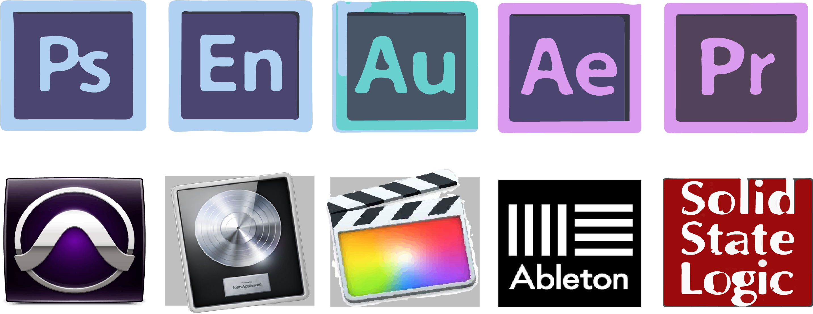
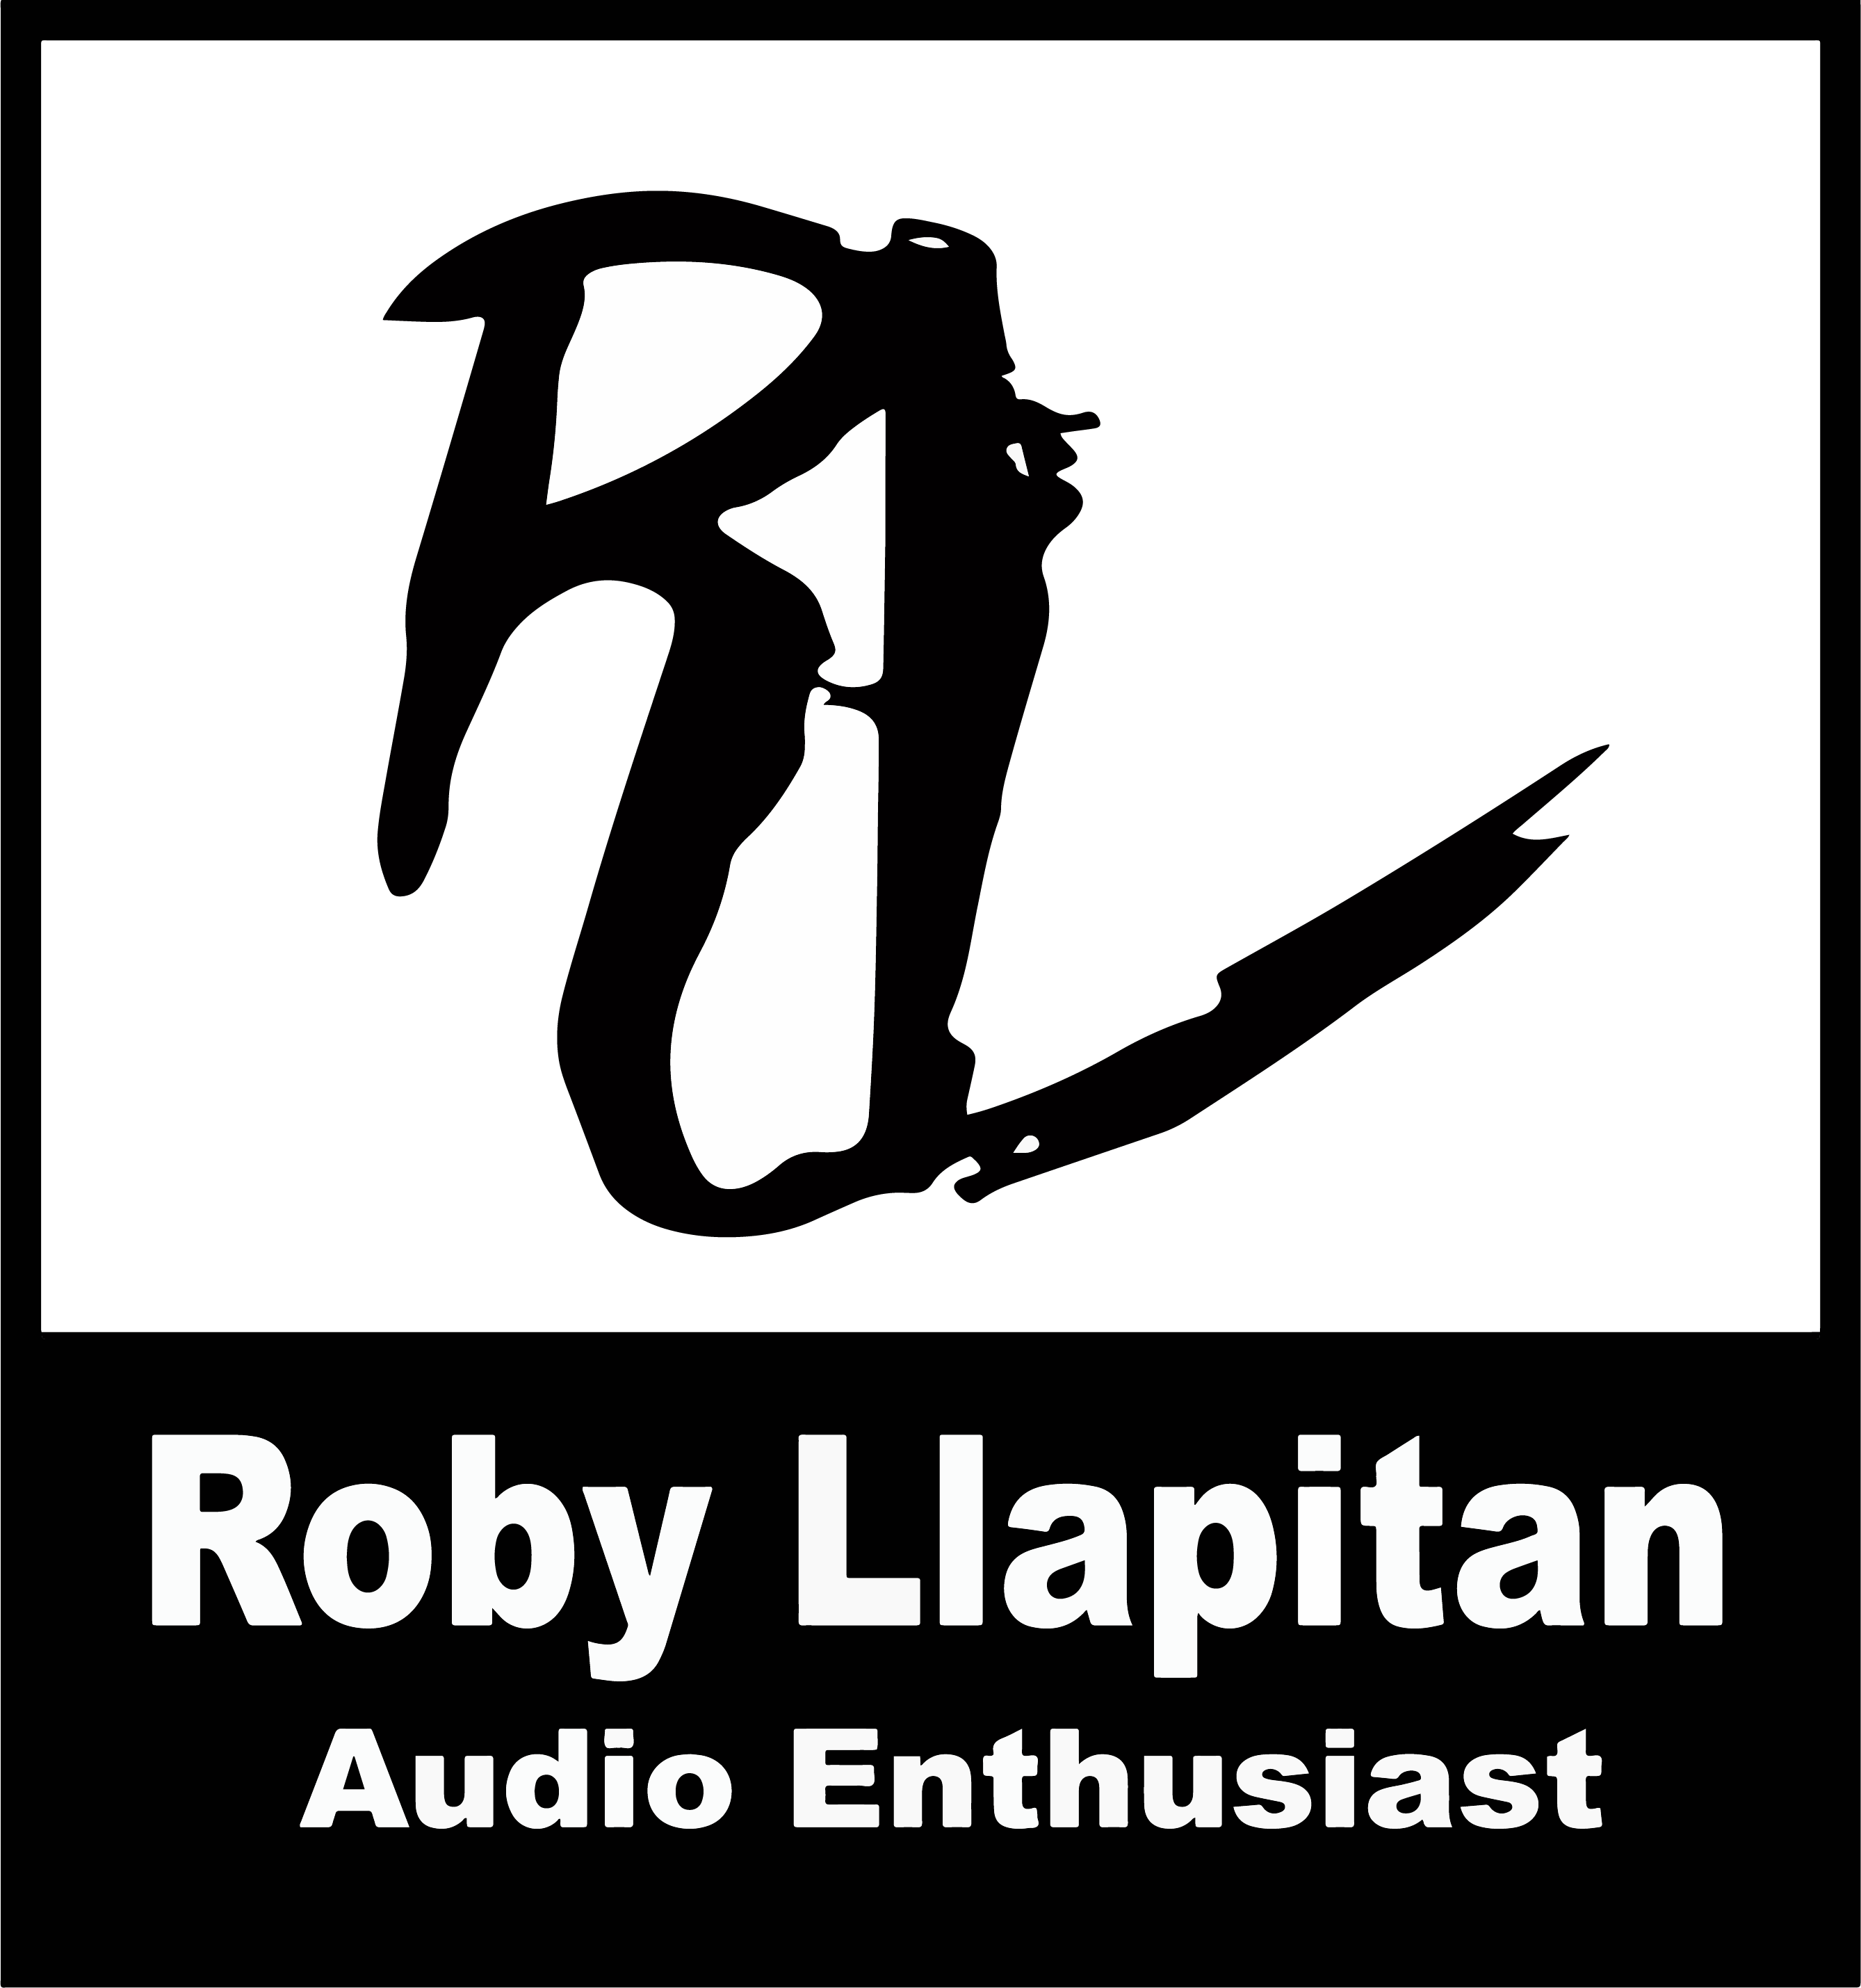
C: 702-445-2014

W www.rlcreativeaudio.com

E: roby@rlcreativeaudio.com

Roby Llapitan - Audio Production
Summary
Experienced Audio Specialist. Live mixing, Lighting, Studio Mixing,
Post-Production, Dj, Field Sound and Audio Technician.
Freelance:
Field Sound for mini movies
ADR and Foley for mini series
Film/edit docs series
Experience
Product Zone Specialist, Apple Inc. Las Vegas NV
(Oct. 2017- Present)
Help promote Apple by informing customers of features,
benefits and live demos of their products
Professional Audio Instructor, Guitar Center Inc Las Vegas, NV.
(Apr. 2017- July 2018)
Teach students how to record, and produce their own
music as well as DJ
Professional Audio Sales, Guitar Center Las Vegas, NV
(May. 2013- April 2017)
Generate overall revenue by selling musical and audio equipment and providing technical support

Cable Technician, VER (Video Equipment Rentals) Las Vegas, NV April 2017- Oct. 2017
(Repair, organize and QC audio, video and lighting cables for special events)
Education
Bachelor’s Of Science; Audio Production - Art Institute of Las Vegas.
(July 2015- December 2018)
College of Southern Nevada- Business Marketing; Las Vegas, NV
(September 2012- June 2014)
Skills/Certifications
Roby Llapitan

